Longest Common Subsequence

subsequence: that means what we are looking for, doesnt have to be contigious sequence.

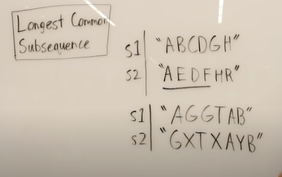

Above is a contigious sequence(i.e altogether and I.e no-gaps)
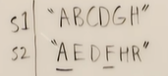

Above is not contigious sequence.
Above A and F is a subsequence.
A subsequence doesnt have to be contigious, but It can be contigious.

So our aim is to find Longest Common subsequence between two Strings.
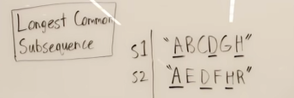

The longest Common Subsequence is ADH. The length is 3.
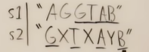
You see S1 is contigious.

But S2 isnt contigious.

We could brute force this problem, we could try to generate all subsequences, this would be exponential in time. So what we are gonna use is dynamic programming.

Whenever I do dynamic programming I care about the subproblems and remembering the answer about the subproblems and things like that.
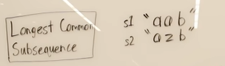

What I am gonna do is breakdown this into a call recursion tree.
What I am gonna do here, is how each call looks like and what decisions we make and what decisions we make at each point at what we see.
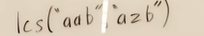

So what I am gonna do, is cut this into sub-problem.
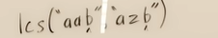

so we see they are the same, so we see there is lengthing of our longest common subsequence by 1 value. So the solution is now 1+ lcs(“aa”,”az”).
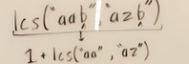

So now,
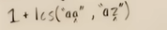

so we Move to the next char.
So,
Are this characters the same?
>>>No
So my job now is to see if I delete either of this characters, which subproblem is gonna yield to me, a better longest common subsequence.
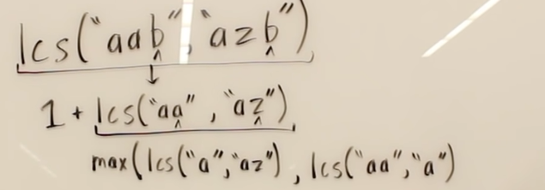

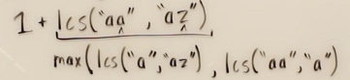

So I broke this subproblem downto if I remove this “a” and I take the longest common subsequence between these two strings.
And then I remove the “z” and I take the longest common subsequence between this two strings.
Whichever of this subproblem yield a larger LCS, I am gonna take that as the LCS for the given subproblem and then add 1 to this in stack frame.

But the key here is the best answer to this subproblem, when we have a mismatching character is, I try removing this character “a” and I solve it and I try removing this character “z” and I solve it.

We are trying to find the best path to take in decomposing the String, so that we can yield the longest Common subsequence and we are chopping off character by character and we wanna see which combination of chopping off char will yield us the longest common subsequence.
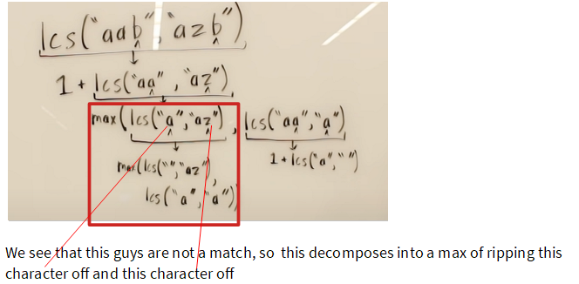

In Blue, we see that there is a match . So there is no competition that needs to happen.
You’ll see this recursive in nature,

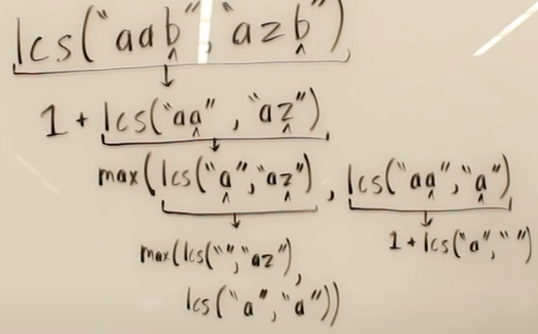

So if either of the String is empty which means there is not going to be a longest common subsequence. I cant have anything in common with an empty String.
So the length of the common subsequence sub-problem is ZERO.
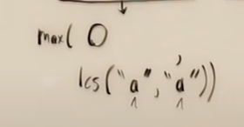

Its a match so we do 1+ lcs().
Remember no competition needs to happen.
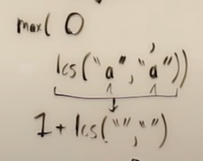
Now, empty String vs an empty String, theres nothing to have in common. If either of them are empty we immediately have a longest common subsequence of zero.

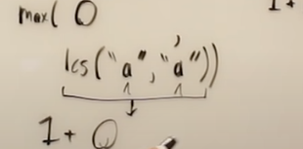
-→max(0,1) >>>1

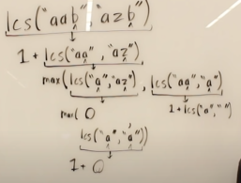

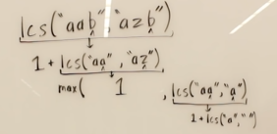

now the LCS( “a”, ””) is zero.
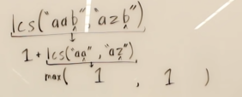

You see we are competing and the competition is which one of the sub-problem is gonna lead to LCS.

There is a competition because this guys didnt match if they did match, we chop both of them off.
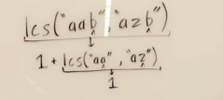

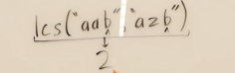

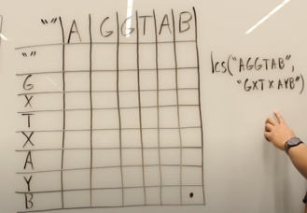
Do u see how it is a function call, all each of this means, its a different substring chopping that we call this function on, they are sub-problems.

Another e.g
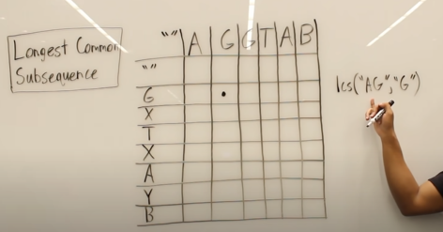
when we are breaking this into sub-problems, this are seperate function calls.

Solution
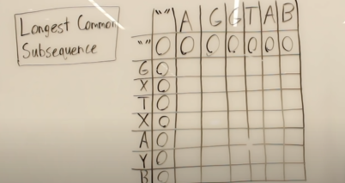

Above its a mismatch, so if I cut the A off I go to the left and if I cut the G off I am going upwards.
Since its a mismatch, there is a competition between

max( LCS(“”, G ) , LCS(A, ””) )
So ans >>> Zero.

Step 2:
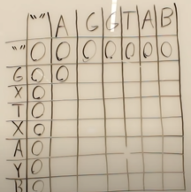
So its a match so I remove both G add 1 to the new subproblem I.e
So our solution to the subproblem is
1+ LCS(“”, A).
What is LCS(“”,A) >>0
So LCS(AG,G) =1;

Here , we are implementing in a bottom up manner.

Similarly,
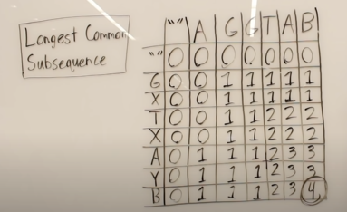

Substring problems and decomposition like this.
